REPUBLIC OF GHANA

COMPOSITE BUDGET

FOR 2022-2025

PROGRAMME BASED BUDGET ESTIMATES

FOR 2022

KUMASI METROPOLITAN ASSEMBLY

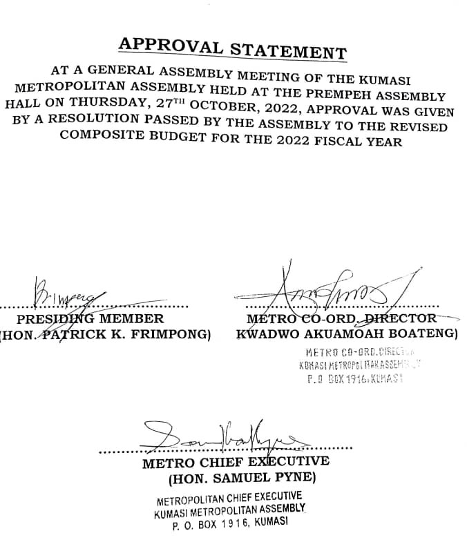

Contents
PART A: STRATEGIC OVERVIEW OF THE KUMASI METROPOLITAN ASSEMBLY 2
ESTABLISHMENT OF THE METROPOLITAN ASSEMBLY 2
LOCATION AND SIZE 2
POPULATION STRUCTURE 2
VISION OF KUMASI METROPOLITAN ASSEMBLY 2
MISSION STATEMENT 2
GOAL 2
CORE FUNCTIONS 2
METRO ECONOMY 2
Key Issues/Challenges 2
KEY ACHIEVEMENTS IN 2021 2
REVENUE AND EXPENDITURE PERFORMANCE 2
MMDA Adopted Policy Objectives for 2022 2
Policy Outcome Indicators and Targets 2
REVENUE MOBILIZATION STRATEGIES FOR MAJOR REVENUE SOURCES 2
PART B: BUDGET PROGRAMME/SUB-PROGRAMME SUMMARY 2
PROGRAMME 1: MANAGEMENT AND ADMINISTRATION 2
PROGRAMME 2: SOCIAL SERVICES DELIVERY 2
PROGRAMME 3: INFRASTRUCTURE DELIVERY AND MANAGEMENT 2
PROGRAMME 4: ECONOMIC DEVELOPMENT 2
PROGRAMME 5: ENVIRONMENTAL MANAGEMENT 2
PART C: FINANCIAL INFORMATION 2

PART A: STRATEGIC OVERVIEW OF THE KUMASI METROPOLITAN ASSEMBLY

ESTABLISHMENT OF THE METROPOLITAN ASSEMBLY
Kumasi Metropolitan Assembly is one of the forty-three (43) districts in Ashanti Region. It was established by Legislative Instrument 2260.

LOCATION AND SIZE
Kumasi Metropolitan Assembly is one of the Forty-Three (43) districts in Ashanti Region. It has a surface area of approximately 78.28 square km. It serves as commercial hub of Ghana. It shares boundaries with Afigya Kwabre South and Kwabre East to the North, Atwima Kwanwoma and Bosomtwe to the South, Asokore Mampong and Oforikrom to the East, Kwadaso to the West, Atwima Nwabiagya North to the North West, Asokwa to the South East and Suame and Old Tafo Municipalities to the North. Kumasi is approximately 275.8km north of the National Capital, Accra.

MAP OF KUMASI METROPOLIS
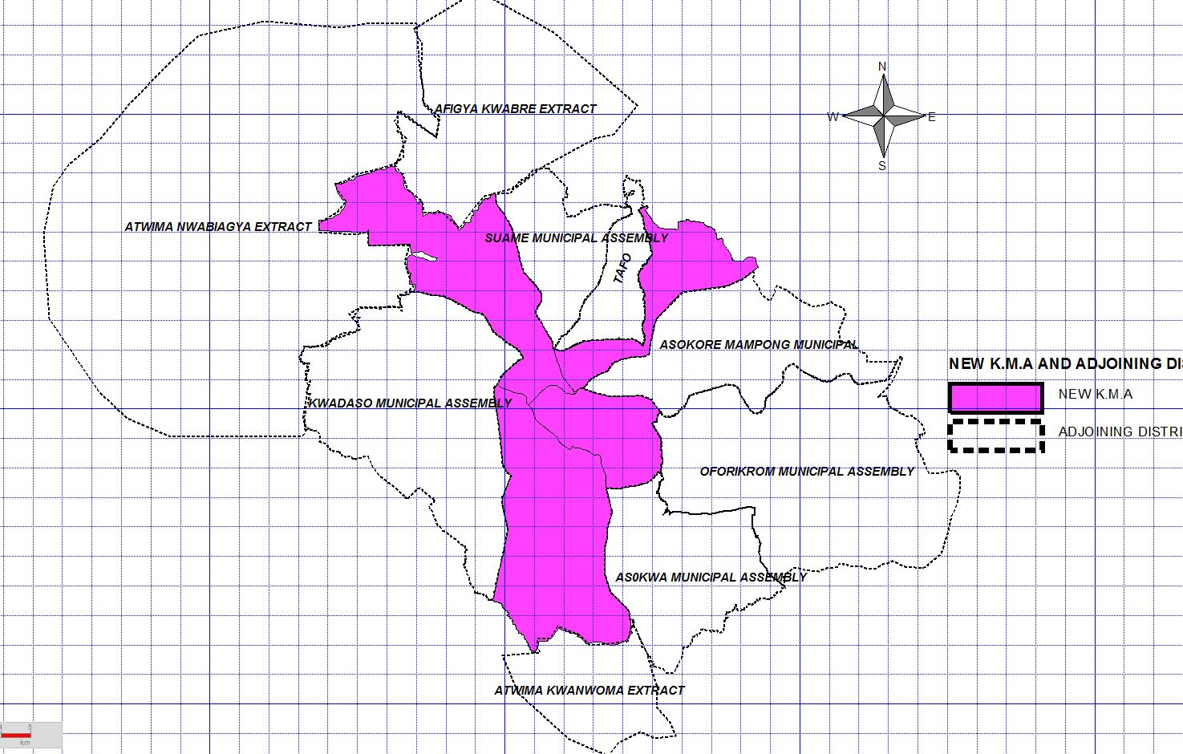

POPULATION STRUCTURE
Kumasi Metropolitan Assembly has a projected population (2021) of 1,120,259 based on an intercensal growth rate of 3.91%. This is a decline of 2010 population of 1,730,249 (GSS, 2014). This is attributable to the elevation of the five (5) Sub-metros to Municipal statuses in 2018.
The city has a population density of 13,022 persons per square kilometer. It accommodates 15.02% of the region’s population. The high population density has resulted in exorbitant rent charges and upsurge of slums and shanty towns. There is also a high pressure on social services like basic schools and healthcare facilities.
Kumasi population comprises 47.3% male and 52.6% female. The dominance of female is attributable to brisk commercial activities in the city. The city also has a broad-based population structure depicting a youthful population which presents high source of labour supply.

VISION OF KUMASI METROPOLITAN ASSEMBLY
To become a Safe, Smart City and Investment destination for both local and international investors.

MISSION STATEMENT
The Kumasi Metropolitan Assembly is committed to improving the quality of life of the people in the metropolis through the provision of essential services and creation of an enabling environment to ensure the total and sustainable development of the city.

GOAL
To create a human settlement that attracts, accelerates and sustains private sector development as well as the initiation and implementation of policies and plans for accelerated economic growth, poverty reduction and improved quality of life of the citizenry.

CORE FUNCTIONS
The Assembly’s core functions are:
- Responsible for the overall development of the district
- Exercise political and administrative authority in the district
- Shall exercise deliberative, legislative and executive function
- Formulate and execute plans, programmes and strategies for the effective mobilisation of the resources necessary for the overall development of the district
- Promote and support productive activity and social development in the district and remove any obstacles to initiative and development
- Initiate programmes for the development of basic infrastructure and provide Municipal works and services in the district
- Responsible for the development, improvement and management of human settlements and the environment in the district
- In co-operation with the appropriate national and local security agencies, be responsible for the maintenance of security and public safety in the district
- Ensure ready access to courts in the district for promoting of justice
- Performs Deliberative, Legislative and Executive functions
- Preparation and submission of Development Plans and Budgets
- Initiate, sponsor or carry out studies that may be necessary for the discharge of any of the duties conferred by LGA Act, 2016 (Act 936) or any other enactment
- In performance of its functions is subject to the general guidance and directions of the President and matters of national policies
- Sponsor education of students from district to fill particular manpower needs of the district especially, in social sector of education and health.

METRO ECONOMY
- Employment Status
About 63 percent of the population aged 15 years to 64 years is economically active while 37 percent are economically inactive. This means, there is abundant labour force for Investors. Out of the 63% labour force, 91% are employed while 9% are unemployed.
Out of the 91% employed, the Private sector contributes 91.2% with the Public Sector contributing 8.8%. Out of the 91.2% private sector employment, 79.2% fall under the private informal and 19.8% under private formal.
38.4% of the employed is engaged in wholesale and retail trading, 13.6% in manufacturing and repairs, 8% in hospitality and service sector and 6.3% in educational sector. Others are 5.3% in transport & storage, 5% in construction and 3.3% in agriculture and forestry.
b. Transportation Network
There are 875.3 km total road length in Kumasi. 28% of these roads are gravel surface. 52% of these road networks are asphalted, surface dressed is 12% whilst unengineered surface is 8%. The road network in Kumasi can be categorised into arterial, collectors and local roads. The road designs have partly contributed to heavy vehicular traffic congestion in the city. It has trans-saharan roads linking Ghana to the landlocked countries in the West African Sub-region.
Kumasi city can be connected from Accra by air transport in addition to road transport services. The airport is about 3.5km from the Central Business District. The current traffic of airport stands at 42,000 passengers a month.
- Education
KMA has 1000 schools ranging from pre-school to tertiary institutions. There are 337KGs, 373 primary, 252 JHS, 22 SHS, 2 Tech/Voc. Schools and 14 Tertiary Institutions. 63.86% of pupil and students attend public schools whilst 36.14% attend private schools. Though more than 65% of schools are privately owned.
Gender parity index (GPI) of Kumasi Metropolis is 1.06 which indicates the dominants of girl child in all levels of education with the exception of Tech/Voc. schools which is 0.63% and SHS which is 0.80%. The net enrollment rate for basic schools is 66:60% with a Gross enrolment rate of 82.70%.
Pupil/Teacher ratios for KG, Primary, JHS, SHS and Tech/Voc. are 24:1, 28:1, 15:1, 16:1 and 15:1 respectively. Pupil/classroom ratios for KG, Primary, JHS, SHS and Tech/Voc. for public schools are 31:1, 34:1, 37:1, 92:1 and 85:1 respectively. This means that, there is lag in the provision of education infrastructure which have resulted in overcrowding especially at the Senior High Schools.
- Health
There are 160 health care facilities in Kumasi Metropolis. These consist of a Teaching Hospitals, 63 Hospitals, 3 Health centres, 60 clinics 37 maternity homes, 5 CHP compounds. The per capita out patient attendance is 0.77. The 10 top major diseases in Kumasi metropolis are malaria-60%, URTI-14%, skin diseases-7%, hypertension-6%, injuries-5%, diarrhea-4%, rheumatic joint cond.-3%, Acute UTI-2%.
Institutional maternal mortality ratio is 443 per 100,000 live births whilst institutional neonatal rate is 0.19%. Doctor patient ratio is 1:14, 606 and nurses to patient ratio is 1:7, 866.
On Covid-19 Kumasi has recorded 5,670 cases. 5545 have recovered with 113 deaths as at October, 2021. Kumasi has 12 active cases of Covid-19. The Assembly has prepared Covid-19 recovery plan to fight this pandemic.

- Tourism
Kumasi has 20 tourist attractions including the following; Manhyia museum, Rattray Park, Manhyia Palace, Military Museum, Kumasi Zoo, Okomfo Anokye sword, Cultural Centre, Central Market, Kumasi City Mall and Kejetia.
Again, 50% of the tourist who visit Ghana do visit Kumasi. There is therefore a need to tap on this to improve tourism numbers in the metropolis. Plans are also under way to ensure the city leverages on the rich culture of the Asante Kingdom to boost tourism by celebrating a Kumasi week annually to sell Kumasi to the rest of the world.

- Water and Sanitation
83% of households have access to pipe-borne water facilities, (11%) depends on well, (2%) boreholes, (1%) on river/stream, (1%) on tanker supply and (1%) on spring/rainwater.
4.3 percent of household in Kumasi use water closet toilets, (36.2%) of household uses public toilets. Moreover, (11.1%) of household use pit latrine whilst (7.2%) depends on KVIP. About (2%) of the households do not have toilet facilities therefore use open defecation. On Waste Management, Kumasi generates an average of 1500 solid waste daily. 83% of solid waste disposal is mainly done on public disposal site of Oti Landfill. This is to be reduced due to the establishment waste recycling plant at Adagya in Bosomtwe district. (11%) is dumped on other dumpsites. (4%) of solid waste is burnt whilst 2% is buried by household. It is only (9%) of liquid waste that is disposed at the waste disposal site at Oti Landfill site.

g. Agriculture
Farming of cereal crops and vegetable are the dominant agriculture produce in the metropolis. About 4 out of 20 households in Agric operational areas practices urban Agriculture. Yields for major crops are 2.1 mt/ha, 3.28mt/ha 12.2mt/ha for Maize, Rice and Spring onion respectively. Backyard farming, the wetlands and river banks across the metropolis are being used for urban agriculture.
Livestock rearing is another farming practices in the metropolis. It is largely limited to the production of small ruminants such as sheep and goats. Agric Extension agent farmer ratio is 1:17.8 aid farmers adopting technology is 50%.
h. Trade & Commerce/Market Facilities
This sector employs (38.4%) of the working population in Kumasi. Most of the trading activities are concentrated at the Central Business District (which covers Kejetia/Central Market, Adum) and the rest of the 26 markets in the city. There are also commodity-based markets dotted around the city. For example, Sokoban Wood Village specializes in the sale of finished and unfinished timer products. Asafo Magazine light industrial area specializes in auto mechanic repairs and sales of spare parts. There is urgent need to extend existing markets and construct new ones to reduce overcrowding, traffic jams and selling on pavements at the CBD.
- Accommodation & Hospitality Services
Kumasi has three (3-star) and 4 star hotels (which include Golden Tulip, Golden Bean, Sunset, Royal Lamerta and Miklin) that can host international conferences. Collectively, the sector employs 8% of the working population making it the third largest employer in the metropolis.

j. Environmental & Climate Change
Kumasi is located in the transitional forest zone with lots of trees and green. However, the rapid spate of urbanization has deprived the city of its green beauty. Out of a total land area of 78.28 km² occupied by the metropolis, only (34.88%) is covered by trees and flowers. The Assembly has introduced “Keep the City Clean and Green (KCCG)” project where more than 60,000 tree seedlings have been planted. The two-thirds of the city’s landscape is covered by residential, commercial, industrial, civil & culture and accessibility infrastructure.
Kumasi metropolis is not shielded from extreme weather patterns caused by the global climate change. The city has witnessed high volume of run-offs from heavy rains coupled with the encroachments on wetlands and nature reserves has resulted in perennial flooding. During the dry season, the city witnesses frequent fire outbreaks at homes and marketing centres leading to loss of lives and properties.
k. Energy
The electricity coverage is 100% in the metropolis. Kumasi has 5 bulk supply points with over 231km of overhead lines and 140.6km underground cables. The monthly electrical energy consumption is averagely 120MW. However, the spate of growth in the metropolis has far outpaced the rate of electricity generation and supply. This has resulted in overloading of feeders and transformers. Thus, the status of electricity supply from the national grid to various parts of the Metropolis is generally characterized by frequent power cuts.
l. Investment Potentials
i. Location Advantage
- Nodal City
- Centre of Commerce
- Trans-West African road network
- Accessible from all parts of the country
- Population Advantage
- Kumasi City is the most populous city in Ghana. It has a population growth rate of 3.9103%
- A population density of 13,022 persons per square meter, it is one of densely populated cities in Ghana.

- Economic Advantages:
- Tax holidays
- Large market/effective demand
- Security and Legal Institutions

- Investment Opportunities
- Multi-Storey Car Park and Bus Terminal
- More than 10,000 cars enter the CBD daily
- More than 500,000 shoppers come to the CBD daily
- Housing Development
- Airport City Housing Development
- Hotel and Recreational Facility at Royal Gold Club
- Manhyia Housing Redevelopment (Rationale: an old settlement degenerated into slum closer to the Asante King)
- Waste to Energy
- Waste generation in Kumasi is growing, largely as a result of increasing population and economic growth
- In 2015/16 it was estimated that total solid waste generation in Kumasi was 756,000 tons, and this is expected to rise. The Kumasi Metropolitan Assembly, striving for investors in waste to energy to help solve the sanitation crises.
- Recreational Facilities
- Large capacity theatre and conference facility
- Amakom Children’s Park reconstruction
- Redevelopment of the Kumasi Zoo
- Rattray Park

Key Issues/Challenges
- Untarred access roads, deplorable culverts and inadequate transportation services
- Inadequate and poor maintenance of school infrastructure
- Inadequate health infrastructure, equipment and logistics
- Fire outbreaks and perennial flooding
- Inadequate toilet facilities and improper waste disposal
- Uncongenial environment for trading in the local market
- Streetism and inadequate security
- Inadequate access to potable water
- Neglected parks and green areas
- Inadequate capacity in sustainable urban farming
- Inadequate jobs

KEY ACHIEVEMENTS IN 2021
- Introduction of a revenue software in generating demand notices (bills) in 2021
- 39 PWDs supplied with funds for medical and educational purposes as well tools for business start ups
- Covid-19 Response – Purchase of PPEs, Sanitizers and Veronica Buckets for staff, some frontline institutions and Communities.
- 136No. Dual desks supplied to schools
- Krofofrom Market construction at 80% completion level (90% for stalls & 75% for stores)
- 1260No. Led bulbs and 200 Coils of 2.5mm Cables procured and installed
- 2 Storey, 6 Unit Staff Bungalow at roofing level
- 4No. Footbridges constructed over streams
- 6,254 food vendors screened and educated
- Nhyiaeso Sub-Metro Office Block constructed
- 2No. Institutional Toilets fenced

- 39 PWDs supplied with funds for medical and educational purposes as well tools for business start-ups – DACF & IGF

- Food and PPE Supplies to Community Members and Institutions
- Covid–19 Food Support to Vulnerable | - Donation of PPE’s to Health Facilities
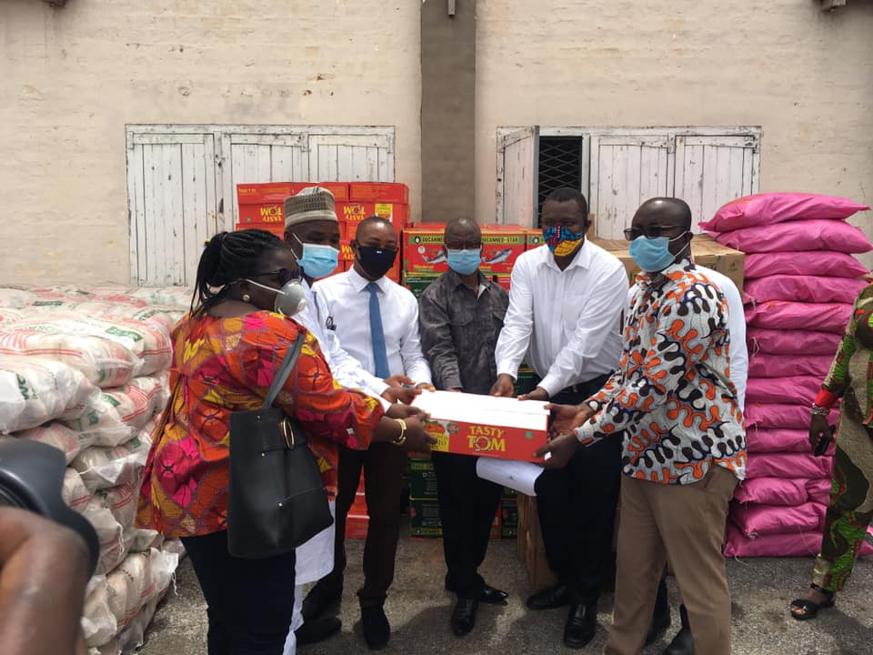  - Donation of Veronica Buckets & PPEs to some Vulnerable Communities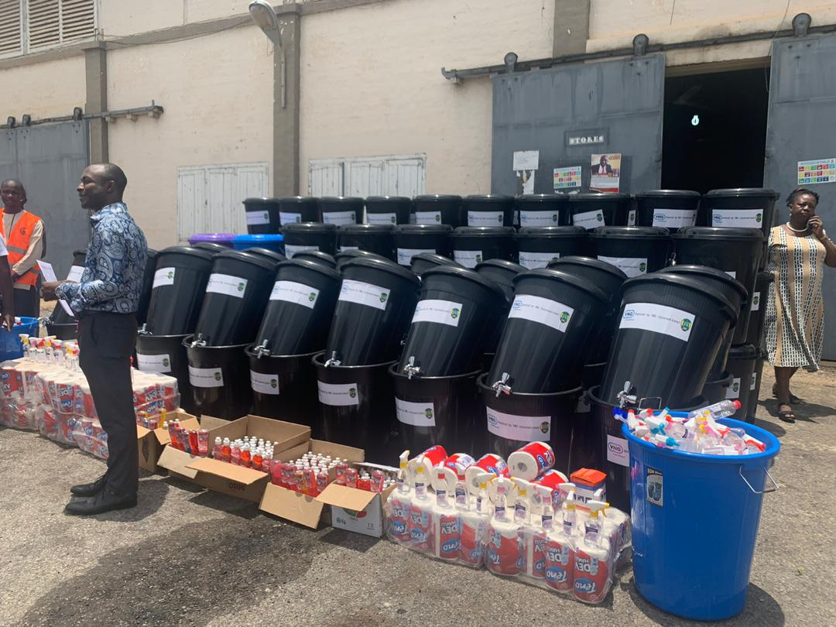 | 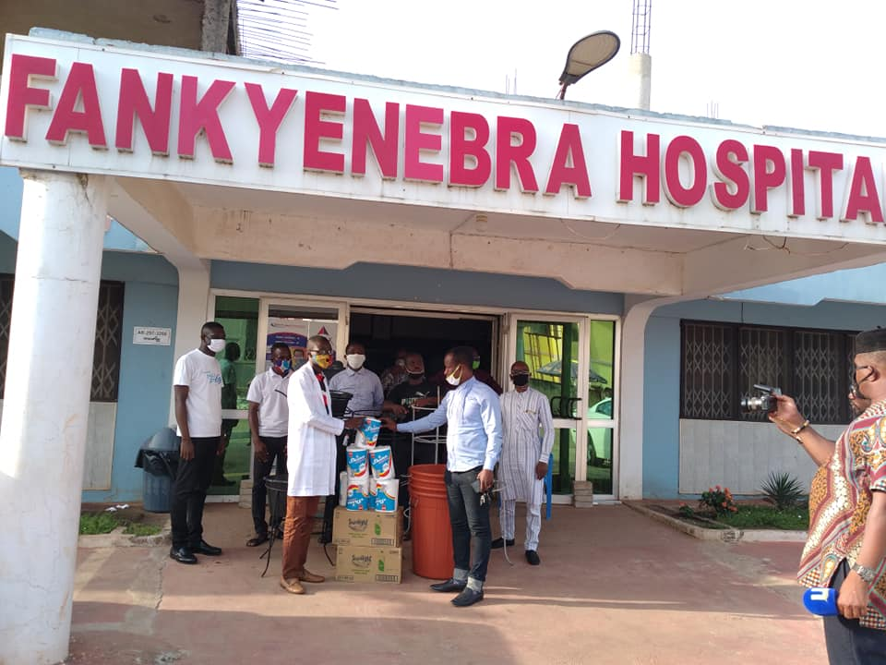  - No. Metal Footbridges Constructed 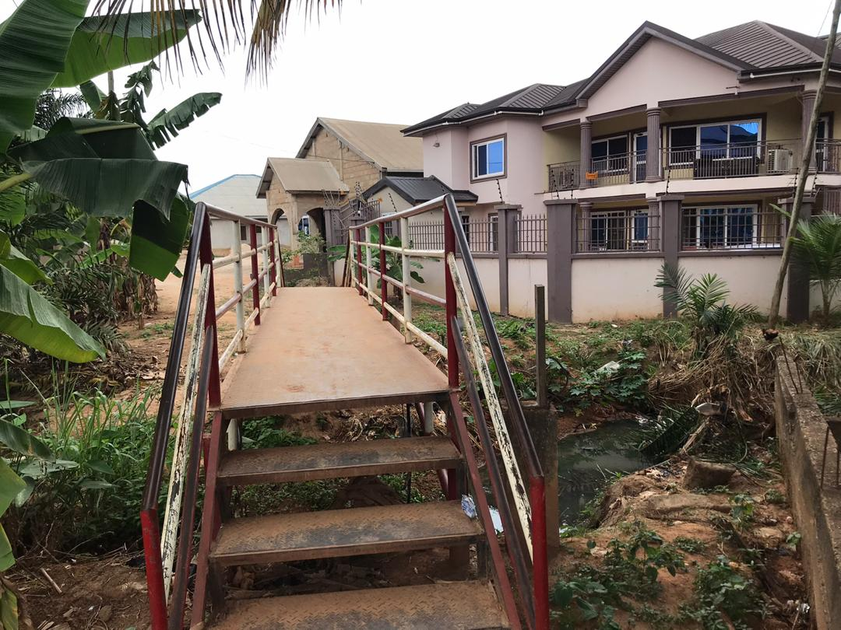

- 2No. Institutional Toilets Fenced
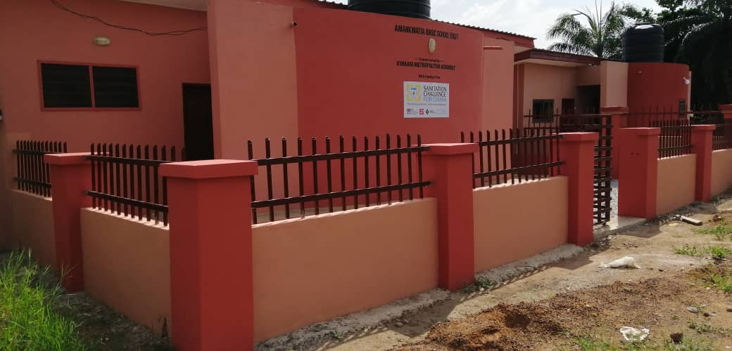

REVENUE AND EXPENDITURE PERFORMANCE
Table 1: Revenue Performance – IGF Only
ITEM | 2019 |  | 2020 |  | 2021 |  | % Perf. as at Jul., 2021
 | Budget | Actual | Budget | Actual | Budget | Actual as at July, 2021
Property Rate | 3,272,478.96 | 3,038,659.92 | 3,060,000.00 | 2,510,725.92 | 4,020,200.00 | 1,889,858.89 | 47.01
Basic Rate | 10,000.00 | - | 10,000.00 | - | 5,000.00 | - | -
Fees | 9,926,000.00 | 9,305,251.94 | 9,771,700.00 | 9,431,206.67 | 8,542,800.00 | 4,683,496.11 | 54.82
Fines | 1,090,000.00 | 998,434.21 | 207,000.00 | 86,134.00 | 202,000.00 | 71,207.00 | 35.25
Licencses | 9,014,521.04 | 8,333,139.92 | 8,773,300.00 | 6,670,735.52 | 8,770,000.00 | 5,033,828.64 | 57.40
Land | 633,000.00 | 452,357.68 | 453,000.00 | 555,720.20 | 790,000.00 | 292,066.19 | 36.97
Rent Investment | 950,000.00 | 464,138.45 | 825,000.00 | 908,326.66 | 1,170,000.00 | 628,864.39 | 53.75
Total | 24,896,000.00 | 23,591,982.12 | 23,100,000.00 | 20,162,848.97 | 23,500,000.00 | 12,599,321.22 | 53.61

Table 1 above indicates that IGF revenue performance of 2019 and 2020 and July, 2021 were 92.85%, 82.05% and as at July, 2021, 47.01% of their respective estimates for the year. The Assemblies continue to put more pragmatic efforts as well as strategies to increase revenue mobilisation to undertake major developments within the metropolis.
b. Revenue Performance – All Revenue Sources
Table 2: Revenue Performance from 2019 to July, 2021
REVENUE ITEM | 2019 |  | 2020 |  | 2021 |  | % Perf. As at Jul., 2021
 | Budget | Actual | Budget | Actual | Budget | Actual as at Jul.,
IGF | 24,896,000.00 | 23,591,982.12 | 23,100,000.00 | 20,162,848.97 | 23,500,000.00 | 12,599,321.22 | 53.61
Compensation Transf. | 9,915,426.54 | 8,402,792.13 | 11,882,023.01 | 13,809,243.48 | 14,783,469.38 | 7,358,067.21 | 49.77
Goods & Services Trans. | 96,769.47 | 13,797.13 | 105,396.52 | 119,709.92 | 172,281.00 | 62,910.86 | 36.52
Assets Transfer | - | - | - | - | - | - | -
DACF | 6,759,439.00 | 3,742,974.49 | 8,846,799.28 | 5,561,010.12 | 8,846,799.00 | - | -
MPs CF | 1,500,000.00 | 1,982,105.05 | 2,269,359.71 | 1,694,601.35 | 1,327,019.76 | 613,908.40 | 46.26
SIF | 100,000.00 | 120,000.00 | - | 80,000.00 | 200,000.00 | - | -
PWD | 352,000.00 | 250,177.63 | 442,339.96 | 77,805.53 | 442,339.86 | 34,815.74 | 7.87
DDF (DACF-RFG) | 10,608,919.32 | 1,606,709.28 | 844,615.38 | 288,054.07 | 900,176.00 | 1,115,329.00 | 123.90
World Bank - Sanipath | - | 772,452.00 | 2,600,000.00 | 253,105.98 | 50,000.00 | - | -
World Bank - AFD | - | 2,760,000.00 | 2,739,399.31 | 261,395.40 | 3,314,400.00 | 319,123.63 | 9.63
World Bank - GKMA | - | - | 5,000,000.00 | - | 2,000,000.00 | - | -
UNICEF | - | - | 70,000.00 | 35,000.00 | 70,000.00 | 35,000.00 | 50.00
MAG | 67,459.70 | 67,459.78 | 67,459.78 | 146,317.10 | 112,075.00 | 41,894.21 | 37.38
GUMPP | 1,000,000.00 | - | - | - | - | - | -
Stool land Transf. | 700,000.00 | 941,858.33 | 900,000.00 | 757,107.18 | 500,000.00 | 184,519.54 | 36.90
Total | 55,996,014.03 | 44,252,307.94 | 58,867,392.95 | 43,246,199.10 | 56,218,560.00 | 22,364,889.81 | 39.78

Table 2 above illustrates the total revenue performance from all sources of the Assembly for the period, 2019, 2020 and July, 2021. The total revenue performance stood at 79.03%, 73.46% for 2019 and 2020.
As at July, 2021, actual total revenue was GH¢22,364,889.61 which represented 39.78% of the total revenue, Grants/GOG transfer and Donor contributed GH¢9,765,568.59 (44.55%) of the total revenue.

- Expenditure Analysis
Table 3: Expenditure Performance – All Sources
EXPENDITURE PERFORMANCE (ALL DEPARTMENTS) ALL FUNDING SOURCES
Expenditure | 2019 |  | 2020 |  | 2021 |  | % Perf as at Jul. 2021
 | Budget | Actual | Budget | Actual | Budget | Actual as at July
Compensation | 13,548,301.74 | 11,639,170.29 | 16,836,606.50 | 18,158,182.03 | 18,644,398.56 | 9,529,218.80 | 51.11
Goods and Services | 20,292,133.70 | 19,027,377.01 | 20,817,911.59 | 18,381,261.31 | 20,707,192.73 | 8,457,002.15 | 40.84
Assets | 22,155,578.59 | 9,812,231.78 | 21,212,874.86 | 10,480,284.60 | 16,866,968.71 | 3,934,626.64 | 23.33
Total | 55,996,014.03 | 40,478,779.08 | 58,867,392.95 | 47,019,727.94 | 56,218,560.00 | 21,920,847.59 | 38.99

As at July, 2021, actual expenditure from all sources was GH¢21,920,847.59 which represented 38.99% of the overall budget of GH¢56,218,560.00. GH¢9,529,218.80 was used to pay salaries for GOG and IGF staff, GH¢8,457,002.15 on Goods and Services and GH¢3,934,626.64 on Assets.

MMDA Adopted Policy Objectives for 2022
- Deepen political and administrative decentralisation
- Enhance capacity high quality, timely and reliable data
- Improve human capital development and management
- Facilitate sustainable and resilient infrastructure development
- Improve transport and road safety
- Sustain reduced waste generation through prevention, reduction, recycling and re-use
- Enhance inclusive urbanisation and capacity for settlement planning
- Ensure free equitable and quality education for all by 2030
- End abuse, exploitation and violence
- Ensure responsible, inclusive, participatory and representative decision making
- Achieve universal health coverage including financial risk
- Protection access to quality health care service
- Promote inclusive and sustainable industrialisation
- Improve production efficiency and yield
- Double agricultural productivity & incomes of small scale food producers for value addition
- Integrate climate change measures
- Inclusive settlements implementing inter climate change and disaster risk reduction

Policy Outcome Indicators and Targets
Table 4: Policy Outcome Indicators and Targets
OUTCOME INDICATOR DESCRIPTION | UNIT OF MEASUREMENT | BASELINE (2019) |  | Past Year 2020 |  | Latest Status (2021) |  |  | Medium Term Target
 |  | Target | Actual | Target | Actual | Target | Actual as at July | 2022 |  | 2023 | 2024 | 2025
Improved performance assessment | % score in DPAT | 100 | 98 | 100 | 0 | 100 | 0 | 100 |  | 100 | 100 | 100
 | % score in performance agreement | 100 | 85.5 | 100 | 0 | 100 | 0 | 100 |  | 100 | 100 | 100
Increased Internally Generated Income | Proportion of IGF to total revenue | 55% | 55.6% | 60% | 48.5% | 60% | 56.4% | 60% |  | 65% | 70% | 70%
Level of compliance of planning and budgeting | % of Budget in the Annual Action Plan | 100% | 98% | 100% | 99% | 100% | 99% | 100% |  | 100% | 100% | 100%
Agric Extension agent farmer ratio improved | Agric Extension farmer ratio | 1:250 | 1:160 | 1:250 | 1:178 | 1:250 | 1:185 | 1:250 |  | 1:250 | 1:250 | 1:250
Increase access of farmers to technology | % of farmers adopting technology in farming | 50% | 45% | 50% | 50% | 60% | 50% | 60% |  | 60% | 70% | 70%
Improved major crops/animal performance | Increase in Maize Yield | 2.2 Mt/ha | 2.2 Mt/ha | 2.5 Mt/ha | 2.1Mt/ha | 2.5 Mt/ha | 2.1Mt/ha | 2.2Mt/ha |  | 2.2Mt/ha | 2.5 Mt/ha | 2.1Mt/ha
 | Increase in Rice Yield | 3.3 Mt/ha | 3.3 Mt/ha | 3.3 Mt/ha | 3.28 Mt/ha | 3.3 Mt/ha | 3.28Mt/ha | 3.3Mt/ha |  | 3.3Mt/ha | 3.3Mt/ha | 3.28Mt/ha
 | Increase in Spring Onion Yield | 11.8 Mt/ha | 12.0 Mt/ha | 12.0 Mt/ha | 12.2Mt/ha | 12.2 Mt/ha | 11.8Mt/ha | 12.0Mt/ha |  | 12.0Mt/ha | 12.0Mt/ha | 12.2 Mt/ha
 | % Increase in Cattle Production | 10% | 15% | 15% | 18% | 20% | 18% | 10% |  | 15% | 15% | 18%
Improved Immunisation Coverage | % Immunisation Coverage | 97% | 99.7% | 97% | 99% | 97% | 84.80% | 97% |  | 97% | 97% | 97%
Reduced Institutional Maternal Mortality | Institutional Maternal Mortality Ratio | 125/100,000 | 612/100,000 | 125/100,000 | 443/100,000 | 125/100,000 | 626/100,000 | 125/100,000 |  | 125/100,000 | 125/100,000 | 125/100,000
Per Capita OPD attendance improved | Per capita OPD attendance improved | 1 | 0.91 | 1 | 0.77 | 1 | 0.70 | 1 |  | 1 | 1 | 1
Increased enrollment in basic schools | Gross enrollment rate | 84.00% | 82.20% | 84.50% | 82.70% | 85% | 82.80% | 85% |  | 90.00% | 90% | 90%
 | Net enrollment rate | 65.50% | 66.30% | 66.80% | 66.60% | 70.00% | 66.40% | 70% |  | 75% | 75% | 75%
 | Gender Parity Index | 1.02 | 1.03 | 1.01 | 1.06 | 1 | 1.06 | 1 |  | 1 | 1 | 1
Improved B.E.C.E Performance | Percentage performance in BECE exams | 68% | 67.40% | 69.50% | 66.30% | 70% | - | 75% |  | 75% | 75% | 75%
Basic access to potable water | % of population with basic access to drinking water | 80% | 74.1% | 80% | 74.10% | 80% | 76.20% | 85% |  | 85% | 90% | 90%
Incidence of Child Abuse reduced | Number of child maintenance cases reported | 120 | 121 | 150 | 113 | 130 | 65 | 130 |  | 130 | 150 | 150
Persons with disabilities having access to Disability Fund | Number of registered PWDs supported with DACF | 150 | 120 | 100 | 44 | 100 | 24 | 100 |  | 100 | 100 | 100
Access to liquid waste disposal | No. of household toilets constructed | 53,176 | 5,312 | 61105 | 5,625 | 70,000.00 | 7,100.00 | 70,000 |  | 70,000 | 70,000 | 70,000
Solid waste disposal improved | Proportion of solid waste properly disposed at the Landfill site | 90% | 80% | 90% | 82% | 90% | 80% | 90% |  | 90% | 90% | 90%

REVENUE MOBILIZATION STRATEGIES FOR MAJOR REVENUE SOURCES
Major revenue source for Kumasi Metropolitan Assembly includes Property Rate, Revenue from Market (toll and rent), On-Street Parking and Lorry Park, Business Operating Permit, Building/Development Permits, Investments in parks and Prempeh Assembly Hall among others. Strategies for enhancing revenue from these sources are;
Table 5: Revenue Mobilization Strategies
S/N | REVENUE ITEM | STRATEGY
1 | Property Rates | The full implementation of a revenue collecting and tracking software (dLRev). POS machines will be bought for revenue collectors. Bio data of ratepayers will be collected.
2 | Market Toll / Lorry Park Tolls & On-Street Parking | A monitoring team would be formed to monitor collection.
3 | Rent | All stores’ data/records of the Assembly are to be updated on the revenue software for effective monitoring on payments.
4 | Business operating Permit | Monitoring will be intensified. DLRev will be used to identify all businesses and reduce leakages.
5 | Building & Development Permits | Increased statutory meetings for permitting purposes. All payments are to be made at the banks by Ratepayers. Development control Task Force formed and resourced.
6 | Rattray, Prempeh Assembly Hall & Jubilee Park | The Assembly continues to partner the contractor in planning attractive packages. A Team has been formed to enhance the monitoring of activities at the Park. Committee has been formed to manage the Prempeh Assembly Hall & Jubilee Park.

PART B: BUDGET PROGRAMME/SUB-PROGRAMME SUMMARY

PROGRAMME 1: MANAGEMENT AND ADMINISTRATION
Budget Programme Objectives
- To integrate and institutionalize planning and budgeting through participatory process
- To provide legislative oversight responsibilities for the Assembly, Sub-district structures and other agencies
- Ensure full political, administrative and fiscal decentralization
Budget Programme Description
The programme seeks to perform the core functions of the Assembly thereby ensuring good governance and balanced development of the district through the formulation and implementation of policies, planning, coordination, monitoring and evaluation. The Programme is being implemented and delivered through the offices of the Central Administration, Budget & Rating, Legal, Human Resource, Finance and Statistical Departments. The various units also involved in the delivery of the programme include; General Administration Unit, Planning Unit, Procurement & Stores Unit, IT Unit, Estates and Internal Audit. It seeks to provide administrative and logistic support services for the smooth operation of departments, Assembly members and Sub-Metropolitan Councils.
The programme is mainly delivered by the staff of the following departments and units
- General Administration
- Planning and Coordination Unit
- Human Resource Department
- Legal Department
- Metropolitan/City Guards (Security) Unit
- Finance Department
- Statistical Department
- Budget & Rating Department
- Internal Audit Unit
- Sub-metropolitan district council
The programme is being implemented with the total support of staff totaling three hundred and eighty-one (381). They include Administrators, Planners, Human Resource Managers, Lawyers, Metro Guards, Internal Auditors, Executive Officers, Drivers, Cleaners and Laborers, Statistical Officers, Budget Analysts, Stenographers, ICT officers, Procurement officers, Accountants the MCE and MCD.
The programme is to be funded with transfers from the Central Government (sector specific transfers and salaries), District Assembly Common Fund (DACF), Donor funds, District Development Facility (DDF) and the Internally General Fund – IGF.
BUDGET SUB-PROGRAMME SUMMARY
PROGRAMME 1: MANAGEMENT AND ADMINISTRATION
SUB PROGRAMME SP1.1: General Administration
- Budget Sub-Programme Objective
The objectives of the General Administration sub programme are;
- Ensure full political, administrative and fiscal decentralization
- Budget Sub-Programme Description
The General Administration sub-programme looks at the provision of administrative support and effective coordination of the activities of the various departments through the Office of the District Co-ordinating Director. The sub-programme is responsible for all activities and programmes relating to general services, procurement/stores, transport, records, protocol services, estates, IT services, public relations and security.
Activities under this sub programme include payment of utilities, general maintenance of Assembly property, providing secretarial services to the Assembly, supply of office equipment and facilities. Organizing statutory programmes, public sensitization programmes just to mention a few.
This sub-programme is carried out by mainly by the staff of Central Administration Department as well as the Sub Metropolitan Councils of the Assembly. A total staff strength of three hundred and twenty-one (321) is expected to ensure the implementation of this sub-programme.
The sources of funds of this sub programme are Internally General Fund, District Assemblies’ Common fund and transfers from Central Government.
Beneficiaries of the sub programme are the staff of the Assembly, Assemblymembers and the general public. The challenges include inadequate funds and logistics.
- Budget Sub-Programme Results Statement
The table indicates the main outputs, its indicators and projections by which the performance of this sub-programme is measured. The past data indicates actual performance whilst the projections are the estimates of future performance.

Table 6: Budget Sub-Programme Results Statement
Main Output | Output Indicator | Past Years |  | Projections
 |  | 2020 | July, 2021 | Budget Yr. 2022 | Indicative Yr. 2023 | Indicative Year 2024 | Indicative Yr. 2025
Annual Progress report submitted | Submission date | 7/2/2021 | 8/2/2022 | 7/2/2023 | 8/2/2024 | 8/2/2025 | 5/2/2026
Town hall meetings organised | No of Town Hall meetings organised | 3 | 2 | 4 | 4 | 4 | 4
Management/HOD meetings held | No. of HODs meetings held | 10 | 4 | 12 | 12 | 12 | 12
Entity Tender Committees Meetings Held | No. of Entity Tender Board meeting held | 12 | 5 | 12 | 12 | 12 | 12

- Budget Sub-Programme Standardised Operations and Projects
Table 7: Budget Sub-Programme Standardized Operations and Project
Standardized Operations | Standardized Projects
Internal management of the organization | Invest in broadband internet infrastructure to support uptake of e-commerce at the Central Business District
Procurement of Office Equipment and Logistics
Protocol Services
Acquisition of Movable and Immovable Assets

PROGRAMME: MANAGEMENT AND ADMINISTRATION
SUB PROGRAMME SP 1.2: Finance and Audit
- Budget Sub-Programme Objective
The objectives of this sub-programme are to;
- Ensure effective and efficient management of financial resources
- Budget Sub Programme Description
The Sub-programme provides effective and efficient management of financial resources and timely reporting of the Assembly finances as contained in the Public Financial Management Act, 2016 (Act 921). It also ensures that financial transactions and controls are consistent with prevailing financial and accounting policies, rules, regulations, and best practices. The major activities undertaken by the Sub-programme include: undertaking revenue mobilization activities of the Assembly, keep, render and publish financial statements, keep receipts and custody of all public and trust monies payable into the Assembly and facilitates the disbursement of legitimate and authorized funds.
The total number of staff to carry out this sub-programme is 65 which consisted of Accountants, Internal Auditors, Revenue collectors and officers. Funding for this sub-programme are from GoG transfers, District Assemblies’ Common Fund, Internally General Fund (IGF), and DACF-RFG.
The beneficiaries of this sub-program are the departments, Ratepayers, CAGD, IAA, Financial Institutions, Outsourced Companies, Contractors, Allied Institutions and the general public. This sub-programme in delivering its objectives is confronted by inadequate data on rateable items, inadequate logistics for revenue mobilization and public sensitization, untimely releases of funds and revenue leakages.
The beneficiary of the sub-programme is the Assembly and the general public.
- Budget Sub-Programme Results Statement
The table below indicates the main outputs, its indicators and projections by which performance of this sub-programmes is measured. The past data indicates actual performance whilst the projections are the estimates for future performances.

Table 8: Budget Sub-Programme Results Statement
Main Output | Output Indicator | Past Years |  | Projections
 |  | 2020 | 2021 | Budget Yr. 2022 | Indicative Yr. 2023 | Indicative Year 2024 | Indicative Yr. 2025
Prepare monthly financial statements | Number of financial statements prepared and submitted | 12 | 7 | 12 | 12 | 12 | 12
Organise Audit Committee (AC) meetings | No. of AC meetings organised | 4 | 3 | 4 | 4 | 4 | 4
Total IGF Collected | Actual amount collected (GH¢m) | 20.163 | 12.60 | 26 | 28.6 | 30.3 | 31.5

- Budget Sub-Programme Standardized Operations and Projects
Table 9: Budget Sub-Programme Standardized Operations and Projects
Standardized Operations | Standardized Projects
Treasury and Accounting Activities | Procure and Utilise 50No. Point of Sale (POS) Devices
Internal Audit Operations
Revenue Collection and Management

BUDGET SUB-PROGRAMME SUMMARY
PROGRAMME 1: MANAGEMENT AND ADMINISTRATION
SUB-PROGRAMME 1.3 Human Resource Management
- Budget Sub-Programme Objective
- To provide Human Resource Planning and Development of the Assembly
- Budget Sub-Programme Description
The Human Resource Management seeks to improve capacity of the manpower of the departments, division and unit’s which will ultimately improve the workforce and organizational effectiveness. In carrying out this sub-programme, it is expected that productively would be enhanced at the Assembly.

Major services and operations delivered by the sub-programme include human resource auditing, upgrading and promotion of staff. It also includes Human Resource Management Information System which ensures frequent update of staff records through electronic means, facilitation of recruitment and selection as well as postings of competent staff to fill available vacancies at the district.
Nine (9) staffs will carry out the implementation of this sub-programme, The main funding comes from GoG transfers, DACF-RFG and Internally General Fund. The work of the human resources management is challenged with limited logistics. The sub-programme is beneficial to staff of the Departments of the Assembly, Office of the Local Government Service, CAGD, RCC and the general public.
- Budget Sub-Programme Results Statement
The table indicates the main outputs, its indicators and projections by which Metropolitan Assembly measures the performance of this sub-programme. The past data indicates actual performance whilst the projections are the Assembly’s estimate of the future performance.
Table 10: Budget Sub-Programme Results Statement
Main Output | Output Indicator | Past Years |  | Projections
 |  | 2020 | July, 2021 | Budget Yr. 2022 | Indicative Yr. 2023 | Indicative Year 2024 | Indicative Yr. 2025
Appraisal of staff annually | Number of staff appraised | 450 | 355 | 650 | 850 | 850 | 850
Prepare and implement capacity building plan | No. of Assembly and Town council members trained | 141 | 68 | 150 | 200 | 200 | 200
 | Number of staff training organised | 4 | 4 | 3 | 3 | 3
Salary Administration | Monthly validation | 12 | 8 | 12 | 12 | 12 | 12
- Budget Sub-Programme Standardized Operations and Projects
Table 11: Budget Sub-Programme Standardized Operations and Projects
Standardized Operations | Standardized Projects
Performance Management
Staff Training and Skills Development

PROGRAMME 1: MANAGEMENT AND ADMINISTRATION
SUB PROGRAMME SP1.4: Planning, Coordination and Statistics
- Budget Sub-Programme Objective
The objectives of this sub programme are to
- To integrate and institutionalize development planning and monitoring through participatory process
- To improve accessibility and use of existing database for analysis and decision making
- Budget Sub Programme Description
The Sub-programme coordinates data collection and analysis, preparation and implementation of the District Medium Term Development Plan, Monitoring and evaluation. It collects and collate database for analyses and decision making. The main unit for the delivery is the Planning Unit and Statistics Department.
A total staff strength of Eight (8) will carry out this Sub-programme.
Donor, DACF-RFG, IGF and DACF are the major sources of funds for Planning, Coordination and statistics sub-programme. The main challenges are the untimely releases of funds and inadequate logistics
The beneficiaries of the sub-programme are the Regional Coordinating Council, MLG&RD, Contractors, NDPC, Contractors, Decentralized and Non decentralized departments, Private sector, Ghana Statistical Service, Donor organizations & Countries.
- Budget Sub-Programme Results Statement
Table 12: Budget Sub-Programme Results Statement
Below is the table containing the main outputs, its indicators and projections by which the Assembly measures performance of this sub-programme. The past data indicates actual performance whilst the projections are the estimates of the future performance.
Main Output | Output Indicator | Past Years |  | Projections
 |  | 2020 | July, 2021 | Budget Yr. 2022 | Indicative Yr. 2023 | Indicative Year 2024 | Indicative Yr. 2025
MPCU meetings organized | Number of meetings held | 4 | 3 | 4 | 4 | 4 | 4
Composite Annual Action Plan prepared | Date of approval | 28/9/19 | 27/9/20 | 26/10/21 | 23/09/22 | 27/09/24 | 24/09/25
Monitoring and Evaluation of projects | Number of monthly monitoring visits organized | 12 | 6 | 12 | 12 | 12 | 12
Data updated | No. of quarterly updates | 4 | 3 | 4 | 4 | 4 | 4
- Budget Sub-Programme Standardized Operations and Projects
Table 13: Budget Sub-Programme Standardized Operations and Projects
Standardized Operations | Standardized Projects
Internal management of the organization
Planning and policy formulation
Coordination and harmonization of data

PROGRAMME 1: MANAGEMENT AND ADMINISTRATION
Sub-Programme 1.5: Legislative Oversights
- Budget Sub-Programme Objectives
The objectives of this Sub-programme are;
- To provide legislative oversight responsibilities for the Assembly, sub district structures and other agencies
- Improve popular citizen participation at district levels
- Budget Sub-programme Description
This sub programme seeks to provide deliberative functions of the Assembly, improve citizen participation and decision making at district and sub-district level and ensure effective maintenance of peace and security of lives and properties, it integrates the activities of the non-decentralized departments, public and private institutions, NGO’s, CBO’s/PBOs and Traditional Authorities.
There are 60 Assemblymembers and 5 Members of Parliament. There are five (5) Sub-metros namely, Nhyiaeso, Subin, Manhyia North, Manhyia South and Bantama.
These functions are mainly performed by the staff of the Central Administration and Sub Metropolitan District Councils.
The sub-programme is carried out with funding from Internally Generated Fund (IGF), DACF, and MP Common Fund and other Constituency funds. The sub programme is challenged with inadequate logistics untimely release of funds.
The beneficiaries of these sub programme are non-decentralized departments, Traditional Authorities Assembly members, Sub-metro councils, town councils, community members, public and private institutions and the general public.
- Budget Sub-Programme Results Statement
The table indicates the main outputs, its indicators and projections by which the Metro Assembly measures the performance of this sub-programme. The past data indicates actual measures the performance of this sub-programme. The past data indicates actual performance whilst the projections are the metro’s estimate of future performance.

Table 14: Budget Sub-Programme Results Statement
Main Outputs | Output Indicator | Past Years |  |  | Projections
 |  | 2020 | 2021 | July, 2022 | Indicative year 2023 | Indicative year 2024 | Indicative 2025
General Assembly meetings held | No. of General Assembly meetings held | 3 | 3 | 3 | 4 | 4 | 4
Functionality of Sub-metros | No. of Sub-Metro Functional | 5 | 5 | 5 | 5 | 5 | 5
Executive Committee meetings held | No. of Executive Committee meetings held | 4 | 4 | 2 | 4 | 4 | 4
METSEC meetings held | No. of METSEC meetings held | 14 | 20 | 8 | 12 | 12 | 12

- Budget Sub-Programme Standardized Operations and Projects
Standardized Operations | Standardized Projects
Internal management of the organization
Table 15: Budget Sub-Programme Standardized Operations and Projects

PROGRAMME SP 1.6: Budgeting and Rating
Budget Sub-Programme Objective
Objectives of this sub programme are to
- Improve public expenditure management and budgetary control
- Budget Sub Programme Description
This Sub-Programme ensures the effective and efficient mobilisation of fiscal resources as well as ensure prudent financial management of the Assembly. It involves mechanisms that promote revenue generation and improve resource management such as preparation of revenue improvement plan and preparation of expenditure warrants to ensure effective resource management.
This sub-programme is carried out by the Budget and Rating Department of the Assembly with a staff strength of Ten (10).
This sub-programme is funded with internally generated fund and GOG.
The beneficiaries of the sub-programme are the Assemblymembers, Ratepayers, Outsourced Companies, Ministry of Finance, Regional Coordinating Council, Ministry of Local Government, Decentralisation and Rural Development, Office of the Head of Local Government Service, Contractors and all departments, sections and units
- Budget Sub-Programme Results Statement
Below are the main outputs, indicators and projections by which the Assembly measures performance of this sub-programme.

Table 16: Budget Sub-Programme Results Statements
Main Outputs | Output Indicator | Past Years |  | Projections
 |  | 2020 | July, 2021 | Budget Year 2022 | Indicative Year 2023 | Indicative year 2024 | Indicative year 2025
Organise Budget Committee meetings | Number of meetings organised | 4 | 3 | 4 | 4 | 4 | 4
Composite Budget prepared | Date of Budget approved | 24/10/19 | - | 23/09/21 | 23/09/22 | 22/09/23 | 26/09/24
Revised estimates Prepared | Revised Budget approved | 24/10/2019 | - | August, 2021 | August, 2022 | August, 2023 | August, 2024
Budget & FFR fora/meeting conducted | No. of meetings held | 2 | 1 | 2 | 2 | 2 | 2

- Budget Sub-Programme Standardized Operations and Projects
Table 17: Budget Sub-Programme Standardized Operations and Projects
Standardized Operations | Standardized Projects
Budget preparation and coordination | Procurement of Office Furniture
Budget Implementation and Performance Reporting
Rating and Billing

PROGRAMME 1: MANAGEMENT AND ADMINISTRATION
SUB PROGRAMME SP1.7: Legal Services
- Budget Sub-Programme Objective
The objective of this sub programme is to provide adequate legal services to support the effective and efficient implementation of policies and programmes of the Assembly.
- Budget Sub Programme Description
This Sub-programme provides adequate technical and logistical support to enhance legal performance of the Assembly. It also ensures that all agreements, contracts and engagements of the Assembly are undertaken in accordance with the required legal provisions and policies to ensure that the desired results are achieved.
Among the activities undertaken through this Sub-programme are provision of logistics and building the capacities of the Metro Guards to enhance their performance. It also supervises the marriage registry.
This Sub-programme is carried out by the Legal Department of the Assembly. It also involves security (Metro Guards) and Marriage Registry. It is expected that a total number of one hundred and forty-five (145) workers will carry out this sub programme.
The funding sources of this sub-programme include Internally Generated Fund, District Assemblies Common Fund and GOG transfer.
Beneficiaries of this sub-programme include the Judicial Service, civil society groups, business community, transport organization, Churches, pedestrians, security services and the general public.
- Table 18: Budget Sub-Programme Results Statement
Main Outputs | Output Indicator | Past Years |  | Projections
 |  | 2020 | 2021 as at July | 2022 | 2023 | 2024 | 2025
Capacity of Metro Guards enhanced | Number of Metro Guards trained and clothed | 20 | 30 | 50 | 50 | 50 | 50
Court cases pursued | Number of Court appearance | 60 | 29 | 56 | 56 | 56 | 56
Marriage & Divorce registered approved | Number of Marriages and Divorce Certificate issued | 50 | 75 | 100 | 100 | 100 | -

- Budget Sub-Programme Standardized Operations and Projects
Table 19: Budget Sub-Programme Standardized Operations and Projects
Standardized Operations | Standardized Projects
Internal Management of the Organization | Construction of 1No. Police Station at Asafo
Acquisition of immovable and movable assets | Construct 1No. Police Quarters at Subin

PROGRAMME 2: SOCIAL SERVICES DELIVERY
Budget Programme Objectives
The objectives of this programme are to;
- Enhance inclusive & equitable access & participation in education at all levels
- Ensure sustainable, equitable and easily accessible healthcare services
- Establish an effective and efficient social protection system
- Ensure sanitation and hygienic environment.
Budget Programme Description
The social services delivery budget programme provides essential services in the areas of education, health, social protection and community development. It ensures the provision of social amenities like educational infrastructure and health facilities.
It ensures access to education and health care delivery and provide social protection to the vulnerable in society. The various departments and units involved with the delivery of the programme include;
- Ghana Education Service
- Ghana Health Service and Environmental Health Unit
- Social Welfare & Community Development
- NYA & National Sports Authority
- Birth and Death Department
The programme is being implemented with the total support of staff of Social Welfare & Community Development, Ghana Health Service, Ghana Education Service, Birth and Death registry and Environmental Health Unit.
The programme is to be implemented with a total staff strength of one hundred and eighty-three (183). They include Health Practitioners, Educationists, Social Workers and Sanitary Officers.
The program involves four (4) sub-programmes. These include
- Education, Youth and Sports Services
- Social Welfare and Community Development
- Public Health Services and Management
- Birth and Death Registration Services
The programme is to be funded with transfers from the Central Government (sector specific transfers, District Assembly Common Fund (DACF), Donor funds, DACF-RFG/DDF and the Internally Generated fund (IGF).

SUB PROGRAMME SP2.1: Education, Youth and Sports Services
- Budget Sub-Programme Objective
- To expand access to quality and adequate teaching and learning infrastructure in public schools
- Budget Sub-Programme Description

The Education, Youth and Sports services sub-programme is responsible for
- Advising the Assembly on matters relating to preschool, primary, junior high schools in the district and other matters that may be referred to it by the District Assembly.
- Co-ordinate the organization and supervision of training programmes for youth in the district to develop leadership qualities, personal initiatives, patriotism and community spirit.
- Advise on the provision and management of public libraries and library services in the district in consultation with the Ghana Library Board.
- Advise the Assembly on all matters relating to sports development in the District.
Organizational units delivering the sub-programme include the Ghana Education Service with funding from the GoG and Assembly’s Internally Generated Funds, Common Fund and DACF-RFG
Major challenges hindering the success of this sub-programme includes delay and untimely release of funds and logistics. Beneficiaries of the sub-programme are the general public, students and pupils, parents, teachers, Ministry of Education, Assemblymembers, Community members, Researchers.
- Sub-Programme Results Statement
The table indicates the main outputs, its indicators and projections by which the Metro Assembly measures the performance of this sub-programme. The past data indicates actual performance whilst the projections are the Assembly’s estimate of future performance;
Table 20: Sub-Programme Results Statement
 |  | Past Years |  | Projections
Main Outputs | Output Indicator | 2020 | 2021 as at July | 2022 | 2023 | 2024 | 2025
Increase/improve educational infrastructure and facilities | Number of classroom blocks constructed | 8 | 3 | 7 | 10 | 10 | 10
 | Number of school furniture supplied | 1000 | 500 | 1500 | 1000 | 1000 | 1000
Improve knowledge in science and math’s. and ICT in Basic and SHS | Number of participants in STMIE clinics | 110 | - | 150 | 200 | 250 | 300
Provide sponsorship for students | Number of students sponsored | 319 | 378 | 200 | 500 | 500 | 500
Organize sports competitions | Number of competitions organized | 20 | 12 | 24 | 24 | 24 | 24
- Table 21: Budget Sub-Programme Results Statement
Standardized Operations | Standardized Projects
Acquisition of immovable and movable assets | Completion of 3No. Classroom Blocks in the Kumasi Metropolis at Santasi MA, Adumanu MA & Abrepo M/A
Supervision and Inspection of Education Delivery | Rehabilitate 10No. Classroom blocks in the Metropolis
Development of Youth, Sports and Culture | Procure 2000 school furniture for schools in the Metropolis
Support to Teaching and Learning Delivery | Construct 50N0. Gender sensitive WASH facilities in basic /second cycle schools
 | Construct 2No. Fence wall around schools in the Kumasi Metropolis
 | Procure & distribute Desktop Computers, Laptops and other ICT equipment to public Schools

PROGRAMME 2: SOCIAL SERVICES DELIVERY
SUB PROGRAMME SP2.2: PUBLIC HEALTH SERVICES AND MANAGEMENT
- Budget Sub-Programme Objective
The objective of this sub program is to ensure sustainable, equitable and easily accessible healthcare services to the people within the metropolis.
- Budget Sub Programme Description
This Sub-Programme seeks to ensure quality medical treatment and adequate infrastructure to patients attending public health facilities. It also strategizes to ensure the fight against the Covid-19 pandemic.
This sub programme is carried out by Health Department (Ghana Health Service) and the Environmental Health Unit. In all, Three Hundred and forty (340) staff are expected to carry out this sub programme. Beneficiaries are patients, toilet operators, food vendors, property owners, PLWHAs, Medical officers and other health professionals and the General public.
The funding source for this programme are GOG support, Internally Generated Fund, District Assemblies’ Common Fund, DACF-RFG SIP and donor support.
Some of the challenges under this programme are inadequate funding, stigmatization against PLWHAs, inadequate health facilities, and congested health facilities due to Covid-19 pandemic.
3. Sub-Programme Results Statement
The table below indicates the main outputs, its indicators and projections by which the Assembly measures the performance of the sub programme;
Budget Sub-Programme Operations and Projects
Table 22: Budget Sub-Programme Operations and Projects
Main Output | Output Indicator | Past Years |  | Projections
 |  | 2019 | 2020 | Budget Year 2021 | Indicative Year 2022 | Indicative Year 2023
Organise MAC meetings | Number of meetings organized | 4 | 3 | 4 | 4 | 4
Covid-19 training organised for staff | Number of staff trained on Covid-19 | 410 | 390 | 500 | 500 | 500
Construct CHPs Compound or community Clinic | Number of CHPs compound or clinics constructed | 0 | 1 | 1 | 0 | 0
Hygiene/public health education conducted | No. of hygiene education conducted | 50 | 24 | 60 | 60 | 60

- Budget Sub-Programme Standardised Operations and Projects
Table 23: Budget Sub-Programme Standardized Operations and Projects
Standardized Operations | Standardized Projects
Acquisition of immovable and movable asset | Construct 2No. Community Clinics at Adoato and Duase
Sanitation Related Expenditures | Rehabilitate and furnish Moshie Zongo Health Centre
Public Health Services | Expand KMA clinic at Adum
Internal Management of the Organisation

PROGRAMME 2: SOCIAL SERVICES DELIVERY
SUB PROGRAMME SP2.3: Social Welfare and Community Development
- Budget Sub-Programme Objective
The objectives of this sub program are to
- Ensure an effective and efficient social protection system
- Ensure effective appreciation of and inclusion of disability issues
- Budget Sub-Programme Description
The Social Welfare and Community Development department is responsible for this sub-programme. Social Welfare aims at promoting and protecting the rights of children, seek justice and administer of child related issues. It provides community care for disabled and needy adults. Community Development is also tasked with the responsibility of promoting social and economic growth in the rural communities through popular participation and initiatives of community members thereby reducing poverty, creating employment and eradicating illiteracy among the adult and youth.

This sub programme is undertaken with a total staff strength of twenty-six (26). It is funded with GoG transfers, DACF (Disability Fund), UNICEF Support, DACF and Assembly’s Internally Generated Funds. Challenges facing this sub-programme include untimely release of funds, inadequate office space and logistics for public education. The office of the Sub-programme is not housed in the main office of KMA.
- Sub-Programme Results Statement
The table indicates the main outputs, its indicators and projections by which the Metropolitan Assembly measures the performance of this sub-programme. The past data indicates actual performance whilst the projections are the estimates of future performance;

Main Output | Output Indicator | Past Years |  | Projections
 |  | 2020 | 2021 | Budget Year 2022 | Indicative Year 2023 | Indicative Year 2024 | Indicative Year 2025
Registered Day Care Centres Visited | Number of Day Care Centres Visited | 60 | 75 | 120 | 150 | 150 | 150
Increased assistance to PWDs annually | Number of beneficiaries | 44 | 24 | 70 | 80 | 80 | 100
Orphans and street children supported | Number of Orphans and street children supported | 855 | 515 | 1300 | 1300 | 1300 | 1500
Child protection and family welfare issues settled | Number of child maintenance cases settled | 113 | 65 | 200 | 200 | 200 | 200
Table 24: Sub-Programme Results Statement

Table 25: Budget Sub-Programme Standardized Operations and Projects
Standardized Operations | Standardized Projects
Acquisition of movable and Immovable assets | Construction of a Holding Centre/Shelter for social victims
Child rights promotion and protection
Social Intervention Programmes
Community Mobilization
Gender empowerment and mainstreaming

PROGRAMME 2: SOCIAL SERVICES DELIVERY
SUB-PROGRAMME SP2:4 Birth & Death Registration Services
- Budget Sub-programme objects
The objective of this sub-programme is
- Ensure adherence of quality standards in birth & death registration
- Budget Description
Budget Sub-programme is responsible for registering births and death in the metropolis.
The sub-programme provides birth and death certificates that facilitate the personal data to obtain passports and other national identities
The Sub-programme is carried out by the Birth and Death Registry. The number of workers engage in this service is ten (10).
The funding sources are the Central Government transfers and funds generated through internal sources.
Beneficiaries of this Sub-programme include, Ministry of Foreign Affairs, Passport applicants, students, Traditional Authorities, Bereaved families, NIA and the general public.
- Budget Sub-Programme Results Statement
The table indicates the main outputs, its indicators and projections by which the Metropolitan Assembly measures the performance of this sub-programme. The past data indicates actual performance whilst the projections are the estimates of future performance.
Table 26: Sub-Programme Results Statement
Main Outputs | Output Indicator | Past Years |  | Projections
 |  | 2020 | 2021 as at July | 2022 | 2023 | 2024 | 2025
Birth and Death Registered | Number of births registered | 23,764 | 18,204 | 24,109 | 24,254 | 24,896 | 25,382
 | Number of deaths registered | 10,482 | 8,918 | 10,643 | 11,348 | 12,582 | 13,395
Birth Certificate issued | Number of birth certificates issued | 238 | 90 | 242 | 243 | 249 | 254

Budget Sub-Programme Standardized Operations and Projects
The table lists the standardised operations and projects to be undertaken by the Sub-programmes
Table 27: Budget Sub-Programme Standardized Operations and Projects
Standardized Operations | Standardized Projects
Internal Management of the Organization

PROGRAMME 3: INFRASTRUCTURE DELIVERY AND MANAGEMENT
Budget Programme Objectives
The objectives of this programme are to;
- Develop human and institutional capacities for land use planning
- Promote resilient urban infrastructural development & maintenance, and basic service provision.
- Ensure sustainable development and management of the transport sector
- To accelerate the provision of affordable and safe drinking water
Budget Programme Description
This Programme provides basic infrastructure support such as housing, roads, water, energy, land use and settlement. It ensures good spatial development, accessibility, traffic safety and the construction and maintenance of public works.
The programme is mainly delivered by the Works, Urban Roads, Transport and Physical Planning Departments. The various units involved with the delivery of the program include;
The programme involves three (4) Sub-programmes. These include;
- Public Works Service
- Urban Roads Management
- Physical and Spatial Planning Development
- Transport and Traffic Management
The programme is being implemented with the total staff of one hundred and sixty-one (161). They include Engineers, Architects, Technicians, Planners, Drivers, Cleaners and Labourers.
The programme is to be funded with transfers from the Central Government (sector specific transfers, salaries) District Assembly Common Fund (DACF), Donor funds (e.g GIZ), District Development Facility (DDF) and the Internally Generated fund – IGF.
The beneficiaries of this programme are Road Users, Estate Developers, Traditional Authorities, Land Owners, Contractors, Public Infrastructure users and the general public.

SUB PROGRAMME SP3.1: Physical and Spatial Planning Development
1. Budget Sub-Programme Objective
The objective of this sub program is to
- To minimise haphazard development of physical structures
2. Budget Sub Programme Description
It assists in the preparation of physical plans as a guide for the implementation of spatial development policies. It also focuses on the landscaping and beautification of the Metropolis. The Physical and Spatial Planning sub-programme is delivered through the Department of Physical Planning and the department of Parks and Gardens in the Metropolis. Major services delivered by the sub-program include; Provision of layout for buildings for improved housing layout and settlement and undertaking street naming, numbering of houses (addressing system) and related issues.
The sub programme is carried out with a staff strength of Thirty (20). The sources of funds for this sub programme are; Internally Generated Fund, Central Government Transfers, District Assembly Common Fund and GIZ support. The challenges of this sub programme are irregular and untimely release of funds, encroachment of land, boundary disputes.
Property owners, Traditional Authorities, Estate Developers general public are the beneficiaries of this sub programme.
3. Sub-Programme Results Statement
The table below indicates the main outputs, its indicators and projections by which the Assembly measures the performance of the sub programme;
Main Output | Output Indicator | Past Years |  | Projections
 |  | 2020 | July, 2021 | Budget Year 2022 | Indicative Year 2023 | Indicative Year 2024 | Indicative Year 2025
Statutory Planning Committee meetings organized | Number of SPC meetings organized | 4 | 2 | 5 | 5 | 5 | 5
Building plans approved | No. of permits granted/approved | 188 | 189 | 300 | 300 | 300 | 300
Table 28: Budget Sub-Programme Results Statement

4. Budget Standardised Operations and Projects
Table 29: Operations and Projects
Standardized Operations | Standardized Projects
Acquisition of immovable and movable Assets
Land Acquisition and Registration
Land Use and Spatial Planning
Internal Management of the Organisation

PROGRAMME 3: INFRASTRUCTURE DELIVERY AND MANAGEMENT
SUB PROGRAMME SP3.2: Public Works Service
- Budget Sub-Programme Objective
The objectives of this sub program are to;
- Facilitate sustainable and resilient infrastructure development & maintenance, and basic service provision.
- Implement integrated water resources management
- Budget Sub Programme Description
The department of Works comprising of former Public Works and Rural Housing Department is delivering the sub-programme. The sub-programme operations include;
- Facilitating the preparation of building permit for developers
- Facilitating the construction, repair and maintenance of public buildings and drains along any streets in the major settlements in the Metropolis.
- Facilitating the provision of adequate and wholesome supply of potable water for the entire Metropolis.
- Assisting in the inspection of projects undertaken by the District Assembly with relevant Departments of the Assembly and Community leaders.
- Provide technical and engineering assistance (consultancy) on works undertaken by the Assembly.
The Public Works Service sub programme is carried out with a total staff strength of sixty-seven (67). The beneficiaries of this sub programme are Assembly staff, property owners contractors, estate developers and the general public. The sources of fund for this sub programme are IGF, DACF, DACF-RFG and Donor funding. The challenges include inadequate and rising cost of maintenance of public structures.
- Sub-Programme Results Statement
The table below indicates the main outputs, its indicators and projections by which the Assembly measures the performance of the sub programme;

Main Output | Output Indicator | Past Years |  |  | Projections
 |  | 2020 | July, 2021 | Budget Year 2022 | Indicative Year 2023 | Indicative Year 2024 | Indicative Year 2025
Construction and renovation of Assembly/Public Properties | Number of properties renovated/constructed | 8 | 5 | 10 | 10 | 15 | 15
Provision of street bulbs | No of bulbs replaced | 600 | 500 | 1000 | 1000 | 1000 | 1000
Provide mechanized boreholes | No of mechanized boreholes provided | 10 | 5 | 10 | 15 | 20 | 20
Table 30: Sub-Programme Results Statement

- Budget Sub-Programme Standardized Operations and Projects
Table 31: Budget Sub-Programme Standardized Operations and Projects
Standardized Operations | Standardized Projects
Acquisition of immovable and movable Assets | Rehabilitate 2No. Mechanized Boreholes
Supervision and Regulation of Infrastructure Development | Extend water connections to 100 households
Supervision and Coordination | Construct 5No. Mechanized Boreholes
Internal Management of the Organization | Rehabilitate Assembly’s Markets & Bungalows
 | Improve infrastructure facilities at slum areas

PROGRAMME 3: INFRASTRUCTURE DELIVERY AND MANAGEMENT
SUB PROGRAMME SP3.3: Urban Roads Management
- Budget Sub-Programme Objective
The objectives of this sub program are to;
- Improve efficiency and effectiveness of transport infrastructure and services
- Budget Sub-Programme Description
This Sub-Programme ensures the provision and management of good and accessible roads.
The activities undertaken through this sub progamme include the construction and maintenance of roads, storm drains, bridges, culverts and walkways.
With a staff strength of six (6), this sub programme is carried out by the Department of Urban Roads of the Assembly.
The sources of funds for this sub programme are; Internally Generated Fund, Central Government Transfers, District Assembly Common Fund, District Development and Road Fund.
The challenges that underpin this sub programme are inadequate and untimely release of funds, unreliable climatic condition and external interference from the public.
The Drivers, Property owners, Traders, Contractors, Ministry of Roads, Vehicles and Car owners, Institutions and General public are the beneficiaries of this Sub programme.
The table indicates the main outputs, its indicators and projections by which the Assembly measures the performance of the sub programme;
- Budget Sub-programme Results Statement
Table 32: Budget Sub-Programme Results Statement
Main Output | Output Indicator | Past Years |  | Projections
 |  | 2020 | July, 2021 | Budget Year 2022 | Indicative Year 2023 | Indicative Year 2024 | Indicative Year 2025
Maintenance of Roads | Km of road improved | 28 | 19.5 | 50 | 50 | 50 | 50
Foot bridges constructed | Number of footbridges constructed | 5 | 0 | 4 | 5 | 4 | 4
Culverts & drains constructed | Number of km culverts | 0 | 1 | 3 | 3 | 2 | 2

- Budget Sub-Programme Operations and Projects
The table lists the main Operations and Projects to be undertaken by the sub- programme.
Table 33: Budget Sub-Programme Standardized Operations and Projects
Standardized Operations | Standardized Projects
Internal Management of the Organisation | Construction of U-Drains, Filling & grading of Roads
Acquisition of movable and immovable assets | Reshape roads in the metropolis
 | Construct 2No. Metal footbridges
 | Procure & Distribute 3,200 complete Street lights in the Kumasi Metropolis

PROGRAMME 3: INFRASTRUCTURE DELIVERY AND MANAGEMENT
SUB PROGRAMME SP3.4: Transport and Traffic Management
- Budget Sub-Programme Objective
The objective of this sub program is to improve efficiency and effectiveness of transport infrastructure and services
- Budget Sub Programme Description
Activities under the sub programme include implementing projects and programmes that would enable decongestion of the central business districts as well as other congested areas within the city such as construction of additional transport terminals and BRT system within a context of a SMART City.
This sub programme is carried out by the Transport Department of the Assembly with a Staff strength of ten (10).
The funding source for this programme are internally generated fund and multi donor fund support.
The beneficiaries of this sub programme are traders, workers, transport operators, terminal managers, international donors and the general public.
The challenges under this programme are inadequate logistics, inadequate terminals and traffic problems.
- Sub-Programme Results Statement
The table below indicates the main outputs, its indicators and projections by which the Assembly measures the performance of the sub programme;

Table 34: Sub-Programme Results Statement
Main Output | Output Indicator | Past Years |  | Projections
 |  | 2020 | July, 2021 | 2022 | 2023 | 2024 | 2025
Meetings and workshops organized for stakeholders | Number of workshops and meetings organized | 20 | 12 | 30 | 30 | 30 | 30
Regulate operations of commercial transport operators | % of Transport operators registered | 83.60 | 96.93 | 100 | 100 | 100 | 100

- Budget Sub-Programme Operations and Projects
The table lists the main Operations and Projects to be undertaken by the sub- programme.
Table 35: Budget Sub-Programme Standardized Operations and Projects
Standardized Operations | Standardized Projects
Acquisition of immovable and movable assets
Internal management of the organization
Management of Transport Services

PROGRAMME 4: ECONOMIC DEVELOPMENT
- Budget Programme Objectives
The objectives of this programme are to
- Ensure sustainable development of Small and Medium Enterprises
- Promote domestic tourism to foster national cohesion as well as redistribution of income.
- Improve agricultural productivity.
- Budget Programme Description
The programme aims at making efforts that seeks to improve the economic well-being and quality of life for the people at the Metropolis by enhancing food safety & security, tourism, creating and retaining jobs. It also seeks to empower small and medium scale business both in the agricultural and services sector through various capacity building modules to increase their income levels. It therefore coordinates investment from both internal and external sources.
The sub-programmes under this programme are Trade and Industrial Development, Agricultural services and management and Tourism Development.
The programme is to be undertaken by the Agricultural, Tourism Development Authority and Trade & Industry/NBSSI/BAC.
The programme is implemented with the total staff strength of thirty (30). They include NBSSI/BAC Officers, Extension Officers, Agric Officers and GTA officials.
The programme is to be funded with transfers from the Central Government (Salaries and sector specific transfers), District Assembly Common Fund (DACF), Donor funds (AFD, CIDA) and the Internally Generated fund (IGF).
The challenges of the programme include non decentralisation of Trade and Industry and Tourism Authority at the offices of the Metro Assembly. There is also disjointed programmes between Manhyia, Cultural Centre and the Metro Assembly on tourism.

PROGRAMME 4: ECONOMIC DEVELOPMENT
SUB-PROGRAMME SP4.1: Trade and Industrial Development
- Budget Sub-Programme Objective
- To ensure sustainable development of SMEs and create employment opportunities.
- Increase access to trading facilities and infrastructure.
- Budget Sub-Programme Description
This Sub-Programme ensures the promotion of trade and industry through the promotion of small and medium enterprises.
Activities under the sub-programme mainly are geared towards building capacities of SMEs on the relevance of engaging in private ventures as well as strengthen public private collaborations.
This sub-programme is carried out by the Trade and Industry Ministry/Department and NBSSI/BAC.
The funding source for this programme are, Central Government funding, internally generated fund, Donor and District Assemblies’ Common Fund. The beneficiaries of this sub programme are Small and Medium Scale Businesses, Traders and the general public.
The challenges under this programme are lack of support for SMEs, inadequate logistics and inadequate data for SMEs.
- Sub-Programme Results Statement
The table below indicates the main outputs, its indicators and projections by which the Assembly measures the performance of the sub-programme;
Table 36: Budget Sub-Programme Results Statement
Main Output | Output Indicator | Past Years |  | Projections
 |  | 2020 | 2021 as at July | 2022 | 2023 | 2024 | 2024
Provide support for SMEs | Number of workshops organized | 2 | 2 | 5 | 5 | 5 | 5
Establish apprenticeship and skill devpt. centres | Number of centres established | 1 | 1 | 2 | 2 | 2 | 2
Factories established under IDIF | Number of factories or businesses established | 0 | 1 | 2 | 2 | 2 | 2
- Budget Sub-Programme Operations and Projects
The table lists the main Operations and Projects to be undertaken by the sub- programme.
Table 37: Budget Sub-Programme Standardized Operations and Projects
Standardized Operations | Standardized Projects
Internal management of the organization
Promotion of Small, Medium and Large-Scale Enterprises
Update data on and Support for SME's

PROGRAMME 4: ECONOMIC DEVELOPMENT
SUB-PROGRAMME SP4.2: Agricultural Services and Management
- Budget Sub-Programme Objective
The objectives of this sub program is to;
- Improve agricultural productivity
- Budget Sub-Programme Description
This Sub-Programme ensures that agricultural productivity is improved in crops production and animal rearing. It also includes training of farmers of best practices and technologies to achieve optimum yield. It involves the provision of logistics to the department of Agriculture for effective service delivery.
This sub programme is to be carried out by the staff of the Department of Agriculture with a staff strength of seventeen (17).
The sources of funds for this sub-programme are Central Government funding, Internally Generated Fund, District Assemblies’ Common Fund and Donor funding (MAG etc.).
Beneficiaries of the sub-programme are farmers, schools, food vendors. Inadequate logistics and unavailability of land due to increasing estate development are the main challenges for this sub-programme. Use of polluted water for vegetable production and unreliable climate conditions are also challenges militating against agriculture in Kumasi Metropolis.
- Sub-Programme Results Statement
Table 38: Budget Sub-Programme Results Statement
Main Output | Output Indicator | Past Years |  | Projections
 |  | 2020 | July, 2021 | 2022 | 2023 | 2021 | 2025
Educate farmers on improved technologies | Number of farmers using improved technologies | 10 | 15 | 20 | 20 | 25 | 25
Train Agricultural extension agents | Number of Agric Extension Agents trained | 42 | 45 | 50 | 50 | 50 | 50
Farmers practicing peri-urban agriculture | No. of demonstration and training organized | 4 | 3 | 4 | 4 | 4 | 4
Youth groups trained on agriculture | Number of youth groups trained in grasscutter, rabbit & mushroom | 9 | 3 | 10 | 10 | 10 | 10

- Budget Sub-Programme Operations and Projects
The table lists the main Operations and Projects to be undertaken by the sub- programme.
Table 39: Budget Sub-Programme Standardized Operations and Projects
Operations | Projects (Investment)
Extension services
Surveillance and Management of Diseases and Pests
Internal management of the organization

PROGRAMME 4: ECONOMIC DEVELOPMENT
SUB PROGRAMME SP4.3: TOURISM DEVELOPMENT
- Budget Sub-Programme Objective
The objective of this sub program is to promote domestic tourism and develop available and potential sites.
- Budget Sub-Programme Description
This Sub programme seeks to make the metropolis a tourist attraction center by providing infrastructure that promotes domestic tourism. It involves the creation of awareness of already existing tourism potentials within the metropolis to the general public.
This sub programme is carried out by Metro Tourism Development Authority. The funding source to carry out this sub programme are Internally Generated Fund and District Assembly Common Fund.
The beneficiaries are the Assembly and the general public.
The challenges of this sub programme are inadequate funds and non-marketing of potential tourist sites.
- Sub-Programme Results Statement
The table below indicates the main outputs, its indicators and projections by which the Assembly measures the performance of the sub programme.
Main Output | Output Indicator | Past Years |  | Projections
 |  | 2020 | July,  2021 | 2022 | 2023 | 2024 | 2025
Radio talk show on tourism carried out | No. of radio talks carried out | 3 | 3 | 4 | 4 | 4 | 4
Develop and distribute Tourism Brochures | Number of brochures developed | 0 | 0 | 1 | 1 | 1 | 1
Table 40: Sub-Programme Results Statement

- Budget Sub-Programme Operations and Projects
The table lists the main Operations and Projects to be undertaken by the sub- programme.
Table 41: Budget Sub-Programme Standardized Operations and Projects
Standardized Operations | Standardized Projects
Development and Promotion of Tourism Potentials
Development and Management of Tourist sites

PROGRAMME 5: ENVIRONMENTAL MANAGEMENT
Budget Programme Objectives
The objectives of this programme are to
- Improve access to sanitation and waste management
- Enhance disaster preparedness for effective response
- Develop and promote nature conservation in urban areas
Budget Programme Description
The Environmental management programme provides a healthy environment that safeguards improved environmental sanitation. This involves the provision of improved sanitation facilities like household toilets and efficient disposal of wastes. It is responsible for the management of disaster and guarantee resource (forest) conservation within the entire metropolis. It also involves tree planning and afforestation.
The programme is being delivered by the Environmental protection and Waste Management, Disaster Prevention and Management and Natural Resource Conservation and Management. The various units involved in the delivery of this programme include:
- Forestry Department and Wildlife
- Waste Management Department
- National Disaster Management Organisation
The programme is being implemented with the total staff strength of One hundred and fifty-six (156). They include Administrators, Planners, Public Health Officers, Public Health Engineers and Sanitary Officers, Disaster Management officers.
The programme is to be funded with transfers from the Central Government, District Assembly Common Fund (DACF), Donor funds, DACF-RFG and the Internally Generated fund - IGF.
The challenges include unplanned cities, inadequate logistics, inadequate hydrants, encroachment of reserved lands limited funding and bad attitudes of residents resulting in flooding and deforestation.

SUB PROGRAMME SP5.1: Disaster Prevention and Management
- Budget Sub-Programme Objective
The objectives of this sub program are to;
- Enhance disaster preparedness for effective response
- Budget Sub-Programme Description
This Sub-programme is responsible for the mitigation and reduction of natural disasters. It puts measures in place to sensitize the public on disaster prone phenomena such as flooding and fire outbreaks. This sub programme is carried out by the National Disaster Management Organisation of the Assembly. The sources of funds for this sub programme are Internally Generated Fund and District Assemblies’ Common Fund and Central Government support. Beneficiaries of this sub programme are disaster affected persons and the general public.
- Sub-Programme Results Statement
The table below indicates the main outputs, its indicators and projections by which the Assembly measures the performance of the sub programme;
Table 42: Budget Sub-Programme Results Statement
Main Output | Output Indicator | Past Years |  | Projections
 |  | 2020 | July, 2021 | 2022 | 2023 | 2024 | 2025
Desilt choked drains and streams | Kilometer of drains desilted | 2.5km | 2.75km | 4.0km | 5.0km | 5.0km | 5.0km
Intensify public education on disasters | Number of sensitization programmes organized | 9 | 4 | 10 | 10 | 10 | 10

- Budget Sub-Programme Standardized Operations and Projects
The table lists the main Operations and Projects to be undertaken by the sub- programme.
Table 43: Budget Sub-Programme Standardized Operations and Projects
Standardized Operations | Standardized Projects
Disaster management activities | Desilt choked drains and streams
Internal management of the organization

PROGRAMME 5: ENVIRONMENTAL MANAGEMENT
SUB PROGRAMME SP 5.2: Natural Resources Conservation and Management
- Budget Sub-Programme Objective
The objective of this sub-programme is to
- Develop and promote nature conservation in urban areas.
- Budget Sub-Programme Description
This Sub-Programme aims at the conservation of natural resources to make them useful for future generations. It focuses on activities that reverse degraded natural resources like planting and nurturing of trees to replace lost ones. It is being supported by Keep Kumasi Clean and Green project (KKCG).
The sub programme is carried out by the Department Forestry and Wildlife.
The funding sources for the Resource Conservation sub programme are internally Generated Fund, District Assemblies’ Common Fund and GoG funds and local donors. The beneficiaries of this sub programme are the general public, property owner, landscapers, Amusement parks.
The challenges confronted by this sub programme are inadequate logistics and selling of nature reserves to developers by traditional authorities
- Sub-Programme Results Statement
The table below indicates the main outputs, its indicators and projections by which the Assembly measures the performance of the sub programme;
Table 44: Sub-Programme Results Statement
Main Output | Output Indicator | Past Years |  | Projections
 |  | 2020 | July, 2021 | Budget Year 2022 | Indicative Year 2023 | Indicate Year 2024 | Indicative Year 2025
Plant and nurture trees | Number of trees planted | 6000 | 2,225 | 6,500 | 6,500 | 6,500 | 6,500

- Budget Sub-Programme Standardized Operations and Projects
The table lists the main Operations and Projects to be undertaken by the sub- programme.
Table 45: Budget Sub-Programme Standardized Operations and Projects
Operations | Projects (Investment)
Internal management of the Organization
SUB PROGRAMME SP5.3: Environmental Protection and Waste Management
- Budget Sub-Programme Objective
The objectives of this sub programmes are;
- Accelerate the provision of improve environmental sanitation
- Budget Sub Programme Description
This Sub-Programme is to enhance the operation and performance of Waste Management, increase access to improved sanitation facilities in the metropolis.
With a total staff strength of sixty-eight (68), this sub programme is carried out by the Waste Management Department and Environmental Health Unit of the Assembly.
The funding source for this sub programme are Internally Generated Fund, DACF-RFG, District Assemblies’ Common Fund, GoG and Donor funds.
The general public is the beneficiary of environmental protection and waste management sub-programme.
The challenges for the sub programme are apathy on the part of citizens towards improved sanitation and inadequate logistics. They also include dispute on the ownership of the final landfill site at Oti and poor roads at the disposal sites.
- Sub-Programme Results Statement
The table below indicates the main outputs, its indicators and projections by which the Assembly measures the performance of the sub programme;
Table 46: Budget Sub-Programme Results Statement
Main Output | Output Indicator | Past Years |  | Projections
 |  | 2020 | July, 2021 | 2022 | 2023 | 2024 | 2025
Procure and distribute communal containers | Number of containers distributed | 2 | 1 | 5 | 5 | 5 | 5
Disposal/Sanitary sites improved | Number of sanitary/Disposal sites improved | 3 | 2 | 3 | 3 | 3 | 3
Household toilets constructed | Number of household toilets constructed | 5,625 | 7,100 | 20,000 | 10,000 | 10,000 | 10,000

- Budget Sub-Programme Operations and Projects
The table lists the main Operations and Projects to be undertaken by the sub- programme.
Table 47: Budget Sub-Programme Standardized Operations and Projects
Standardized Operations | Standardized Projects
Internal management of the Organization | Construct 1No. Waste transfer station at Asafo
Acquisition of immovable and movable asset | Construct 5No. Skip pads in selected communities and procure and distribute 30No. 13m3 Communal Containers
Environmental sanitation and waste management | Support for Landfill Site Maintenance
Solid Waste Management
Liquid Waste Management

PART C: FINANCIAL INFORMATION
S/N | Expenditure Classification | Expenditure Sub-Classification | Arrears | 2022 budget | January | February | March | April | May | June | July | August | September | October | November | December | Total
1 | Compensation of Employee | Salary |  | 15,808,131.29 | 1,317,344.27 | 1,317,344.27 | 1,317,344.27 | 1,317,344.27 | 1,317,344.27 | 1,317,344.27 | 1,317,344.27 | 1,317,344.27 | 1,317,344.29 | 1,317,344.29 | 1,317,344.28 | 1,317,344.27 | 15,808,131.29
 |  | Salary Related Allowance |  | 368,260.92 | 30,688.41 | 30,688.41 | 30,688.41 | 30,688.41 | 30,688.41 | 30,688.41 | 30,688.41 | 30,688.41 | 30,688.41 | 30,688.41 | 30,688.41 | 30,688.41 | 368,260.92
 |  | Non Salary Related Allowance |  | 1,540,000.00 | 92,500.00 | 143,000.00 | 182,000.00 | 122,500.00 | 135,000.00 | 108,000.00 | 124,000.00 | 117,000.00 | 123,000.00 | 118,000.00 | 133,000.00 | 142,000.00 | 1,540,000.00
2 | Goods And Services | GoG |  | 206,205.29 |  |  | 51,551.32 |  |  | 51,551.32 |  | 25,180.00 | 51,551.32 |  | 51,551.32 |  | 206,205.29
 |  | IGF |  | 13,540,100.00 | 1,009,012.00 | 1,434,818.00 | 1,807,659.00 | 746,983.00 | 1,098,301.00 | 1,245,601.00 | 1,140,954.00 | 1,116,279.00 | 508,981.00 | 800,495.00 | 1,123,783.00 | 1,507,134.00 | 13,540,100.00
 |  | DACF(MP) |  | 1,200,000.00 |  | 200,000.00 |  | 300,000.00 |  | 250,000.00 |  | 150,000.00 |  | 150,000.00 | 150,000.00 |  | 1,200,000.00
 |  | DACF (ASSEMBLY) |  | 3,276,007.60 |  | 500,000.00 | 150,000.00 | 50,000.00 | 185,000.00 | 160,007.60 | 650,000.00 | 400,000.00 | 500,000.00 | 500,000.00 | 81,000.00 | 100,000.00 | 3,276,007.60
 |  | DACF(PWD) |  | 234,000.54 |  | 26,000.06 | 26,000.06 | 26,000.06 | 26,000.06 |  | 26,000.06 | 26,000.06 |  | 26,000.06 | 26,000.06 | 26,000.06 | 234,000.54
 |  | DACF-RFG |  | 45,859.00 |  |  |  | 22,929.50 |  |  | 22,929.50 |  |  |  |  |  | 45,859.00
 |  | MAG |  | 65,871.23 |  |  | 16,467.81 |  |  | 16,467.81 |  |  | 16,467.81 |  |  | 16,467.81 | 65,871.23
 |  | UNICEF |  | 42,000.00 |  |  | 4,200.00 | 4,200.00 | 4,200.00 | 4,200.00 | 4,200.00 | 4,200.00 | 4,200.00 | 4,200.00 | 4,200.00 | 4,200.00 | 42,000.00
 |  | AFD/WB |  | 1,700,000.00 |  | 250,000.00 | 50,000.00 | 250,000.00 | 50,000.00 | 150,000.00 | 50,000.00 | 300,000.00 | 250,000.00 | 50,000.00 | 200,000.00 | 100,000.00 | 1,700,000.00
 | Asset | IGF |  | 8,464,132.47 |  | 500,000.00 | 550,000.00 | 1,000,000.00 | 600,000.00 | 1,200,000.00 | 500,000.00 | 1,350,000.00 | 800,000.00 | 700,000.00 | 750,000.00 | 514,132.47 | 8,464,132.47
 |  | DACF(ASSEMBLY) |  | 6,084,014.12 |  | 1,000,000.00 |  | 1,200,000.00 |  | 1,350,000.00 |  | 1,450,000.00 |  | 850,000.00 |  | 234,014.12 | 6,084,014.12
 |  | DACF(MP) |  | 327,000.00 |  | 100,000.00 |  |  | 100,000.00 |  | 27,000.00 |  | 50,000.00 |  | 50,000.00 |  | 327,000.00
 |  | DACF(PWD) |  | 234,000.54 |  |  |  | 84,000.00 |  |  | 45,000.00 |  | 50,000.00 |  | 55,000.54 |  | 234,000.54
 |  | DACF-RFG |  | 554,317.00 |  |  |  | 150,000.00 |  |  | 200,000.00 |  |  | 150,000.00 |  | 54,317.00 | 554,317.00
 |  | UNICEF |  | 8,000.00 |  |  |  |  |  | 8,000.00 |  |  |  |  |  |  | 8,000.00
 |  | GKMA |  | 10,000,000.00 |  | 1,500,000.00 |  | 1,000,000.00 | 500,000.00 | 2,500,000.00 | 1,000,000.00 | 1,000,000.00 | 500,000.00 | 1,000,000.00 | 500,000.00 | 500,000.00 | 10,000,000.00
 |  | STOOL LANDS |  | 500,000.00 | - | - | 150,000.00 |  |  | 150,000.00 |  |  | 150,000.00 |  | 50,000.00 |  | 500,000.00
 | TOTAL |  |  | 64,223,080.00 | 2,604,707.68 | 6,680,707.74 | 3,602,926.87 | 6,691,837.24 | 4,069,907.74 | 8,444,934.41 | 5,129,837.24 | 7,286,691.74 | 4,976,926.81 | 6,034,907.74 | 4,522,459.61 | 4,153,839.14 | 64,223,080.00
61

66

